

Programming Foundations: Git + Databases Design

LAB 2

By AltoTech  
https://medium.com/altotech

28/10/2018

# 

# Introduction

Assuming that we are building an app for food ordering like Uber Eats as shown below. There are three major components of the solution: 1. mobile app for customers, 2. web app for restaurant owners, 3. mobile app for drivers

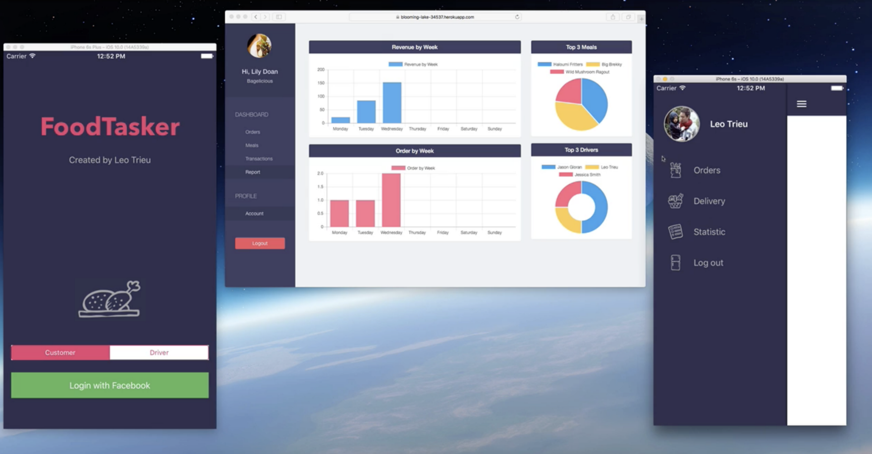

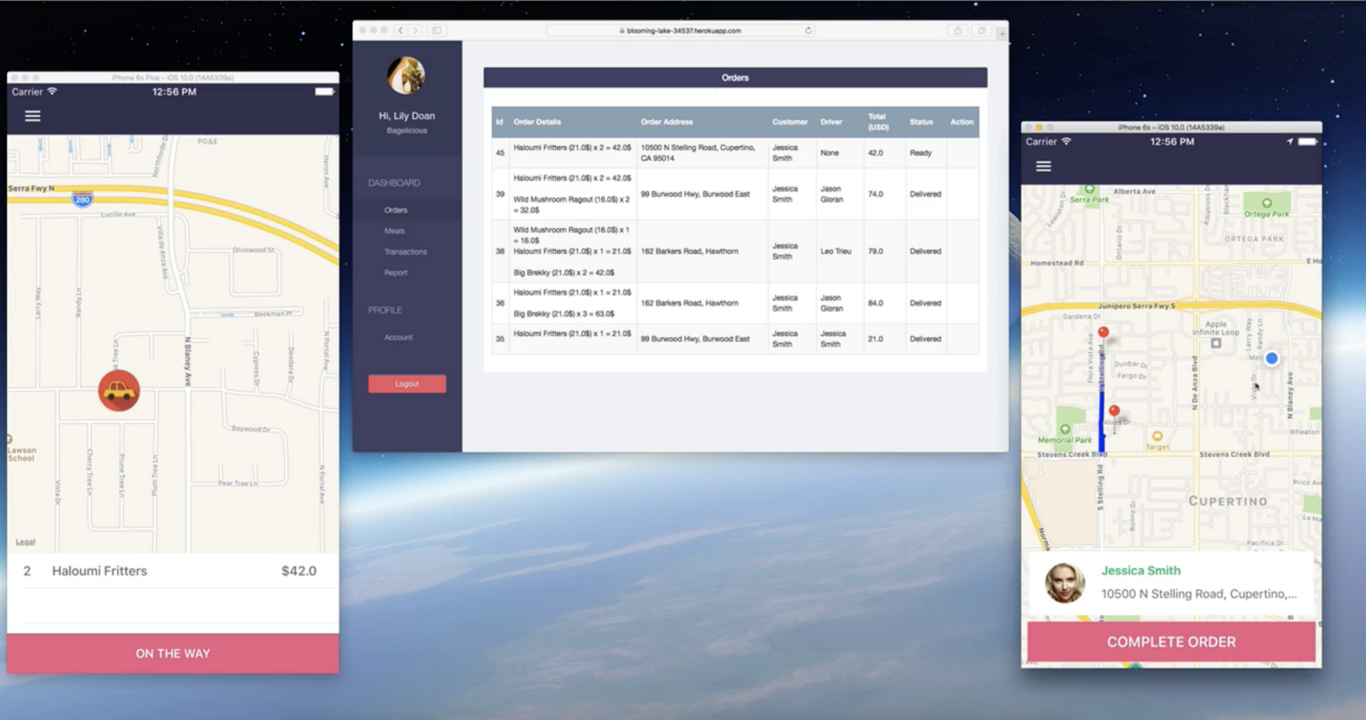

Example of FoodTasker App

Here is the workflow architecture

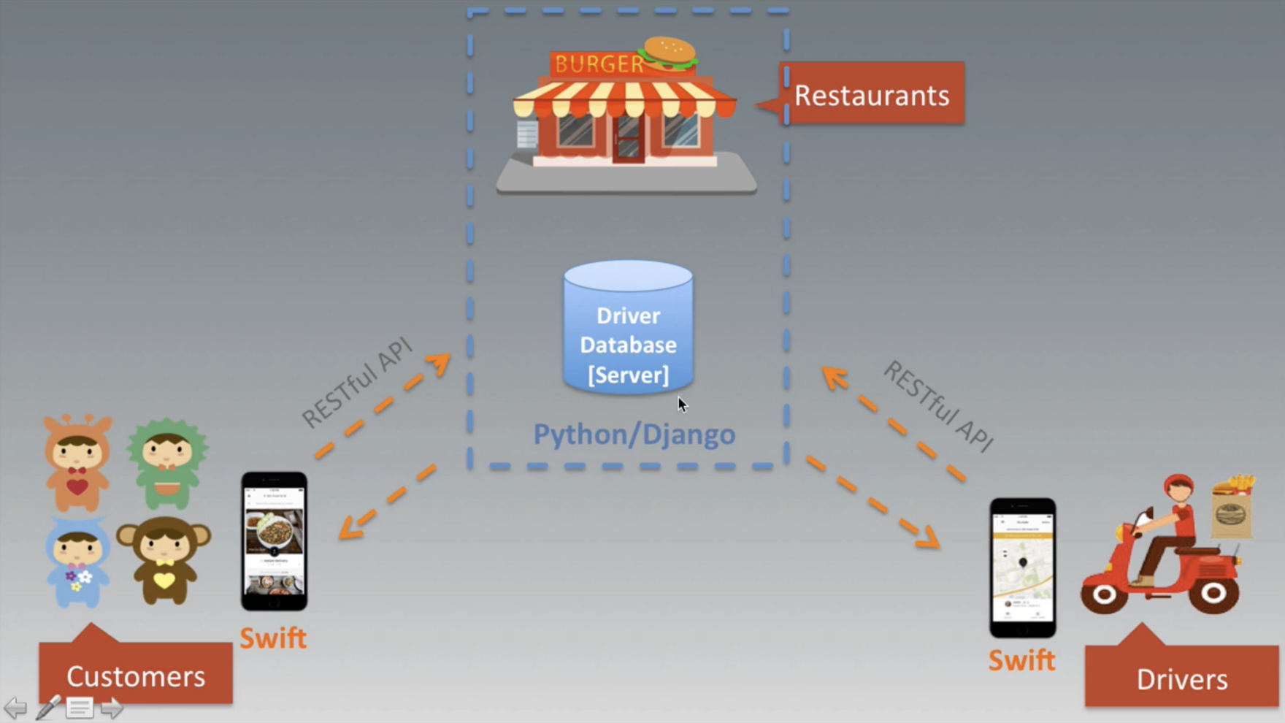

This FoodTasker application can be developed as follows:   
[1] Restaurants Web App: Python Django deployed on GCP, AWS, Azure, or Heroku  
[2] Customers Mobile App: Swift for iOS, Java for Android, or React Native, Flutter   
[3] Drivers Mobile App: Swift for iOS, Java for Android, or React Native, Flutter

# Task 1: Databases Design for FoodTasker App

Based on this example, please answer all of these questions in the context of the Object-Oriented Design.

# Task 2: Setting up Development Environment

**2.1:** **Python 3.5.2**

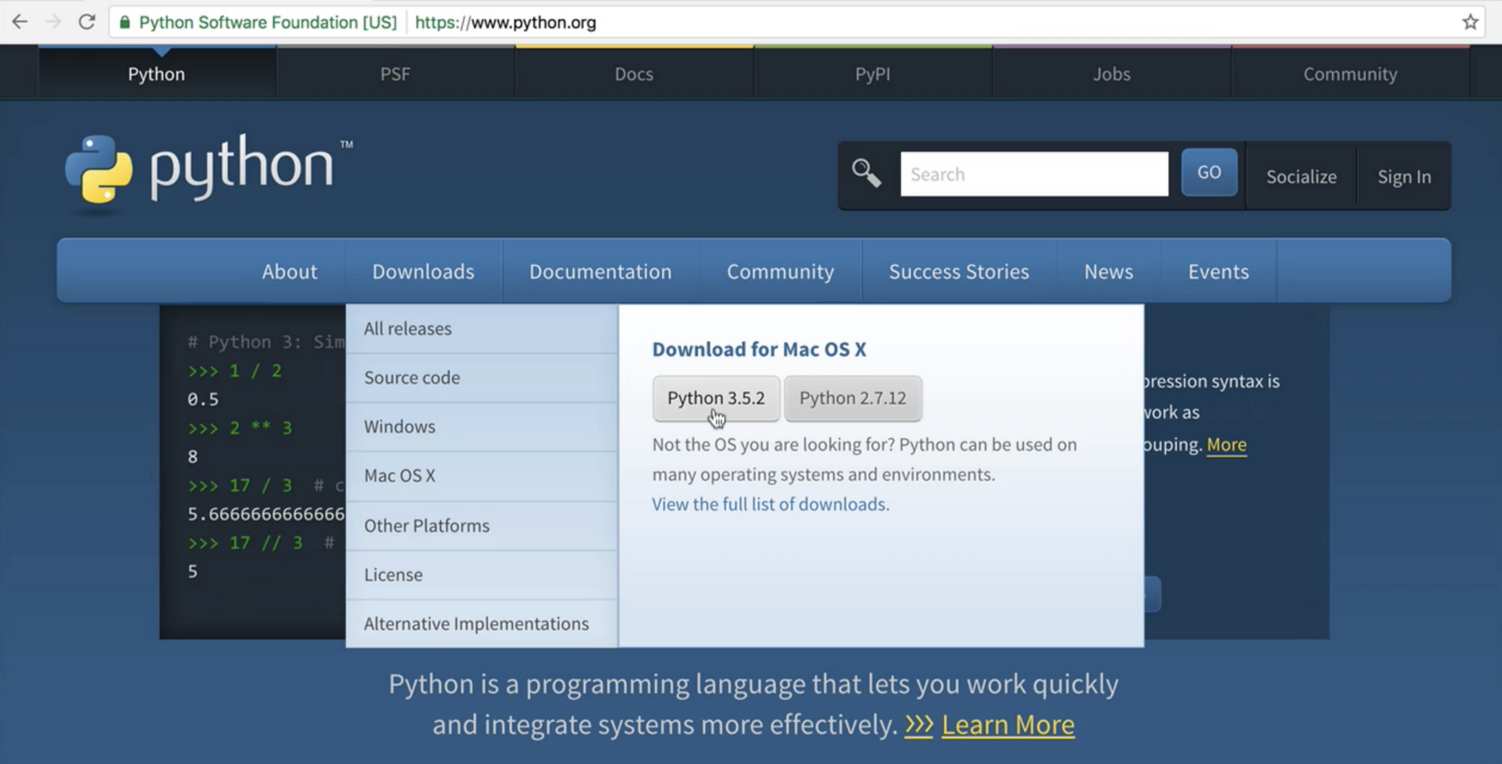

**2.2:** **Heroku**

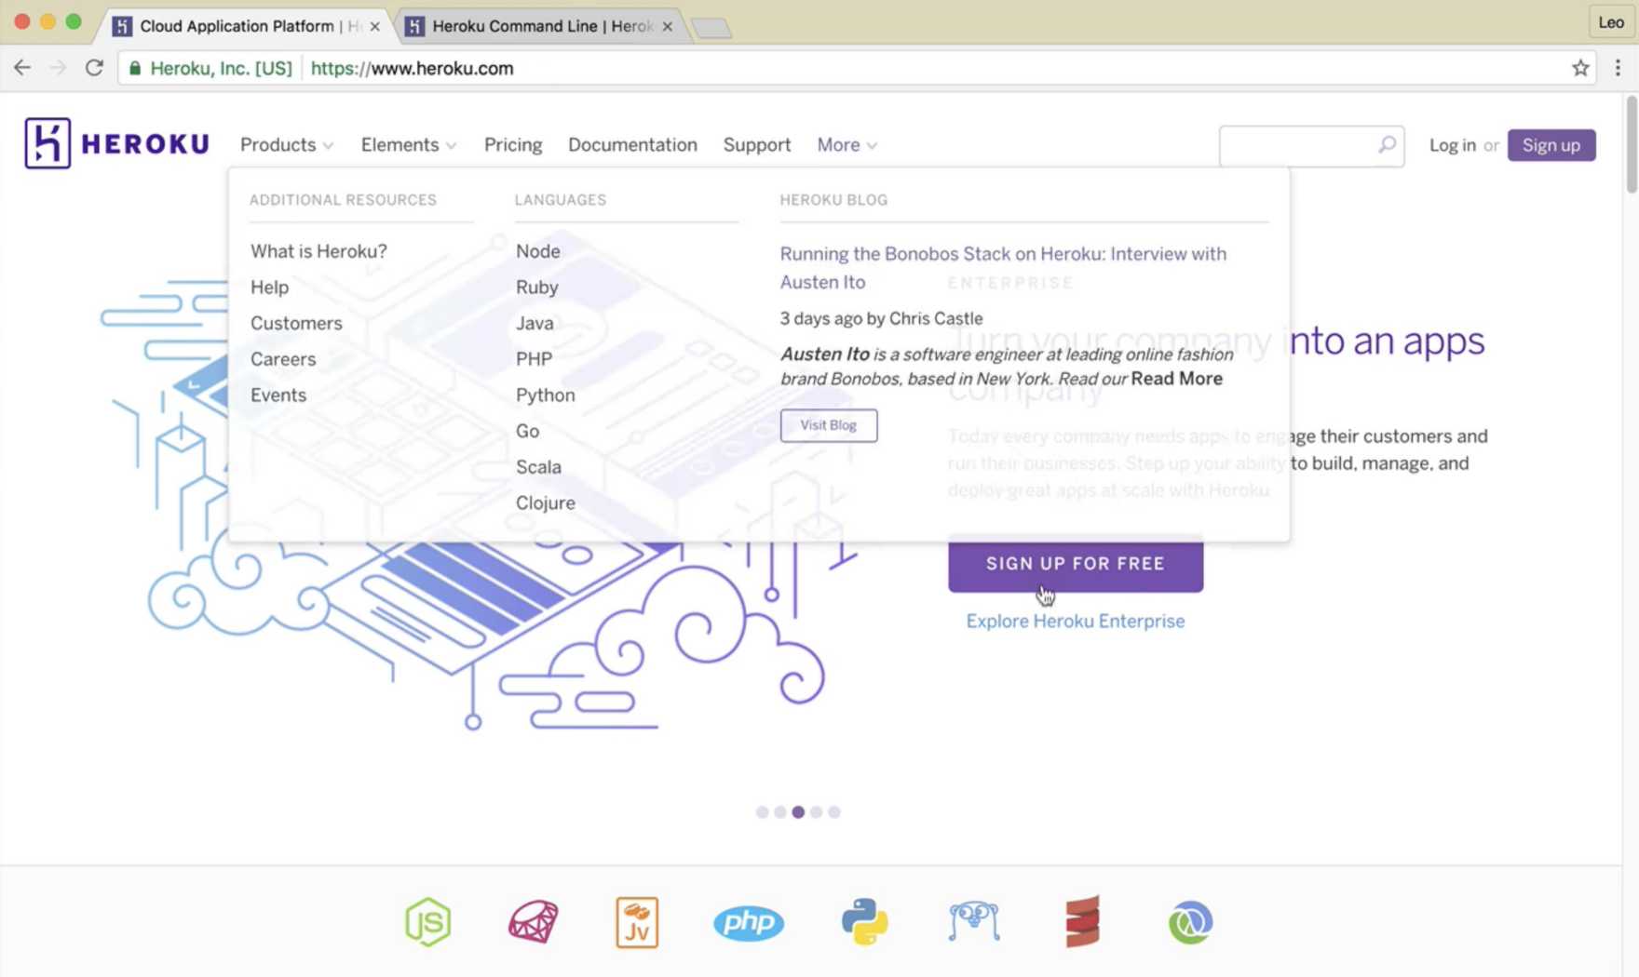

you can download Heroku cli and install at<https://devcenter.heroku.com/articles/heroku-cli>

check if Heroku is installed by typing “$ heroku” in terminal

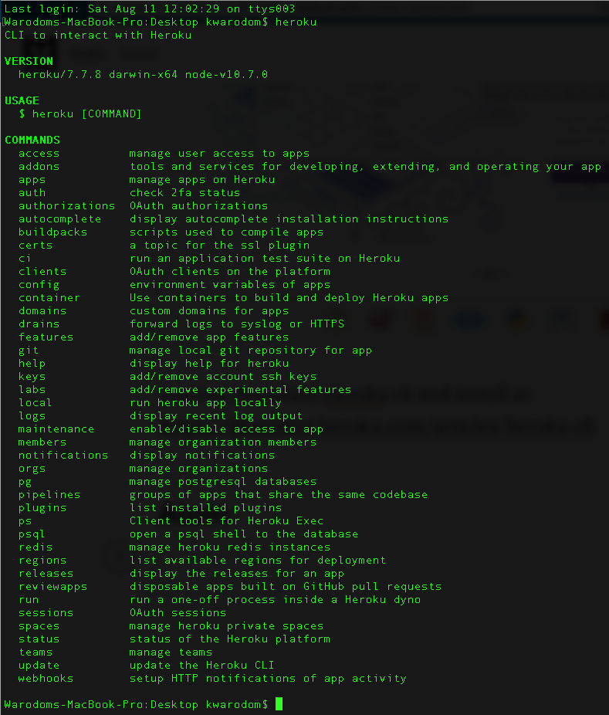

### 2.3: Atom : IDE (**Download Atom at** [**https://atom.io/**](https://atom.io/)**[)](https://atom.io/)**

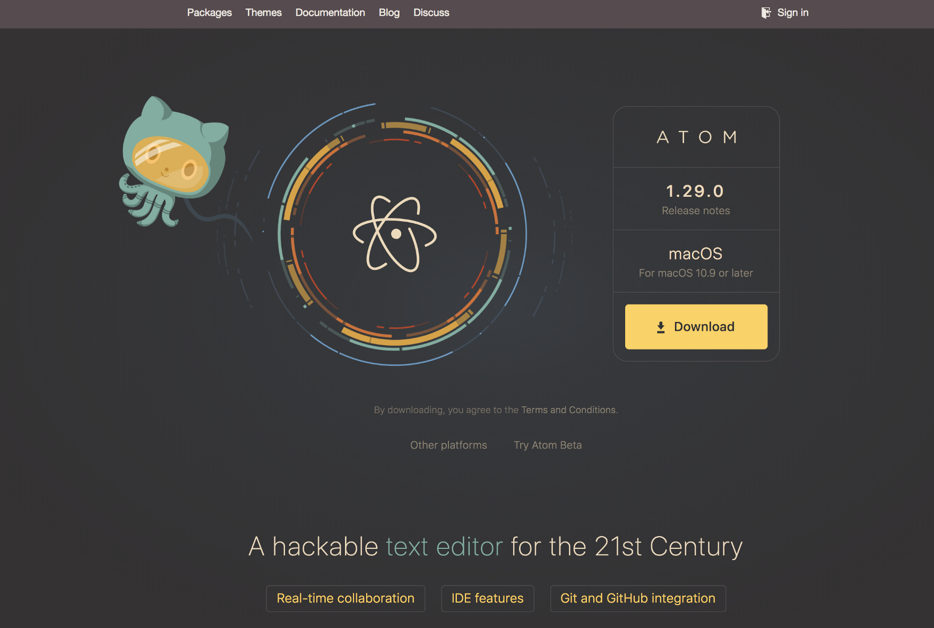

### 2.4: Postman — to interact with RESTful API (Download Postman at<https://www.getpostman.com/>)

### 

### 2.5: Xcode — to develop iOS app

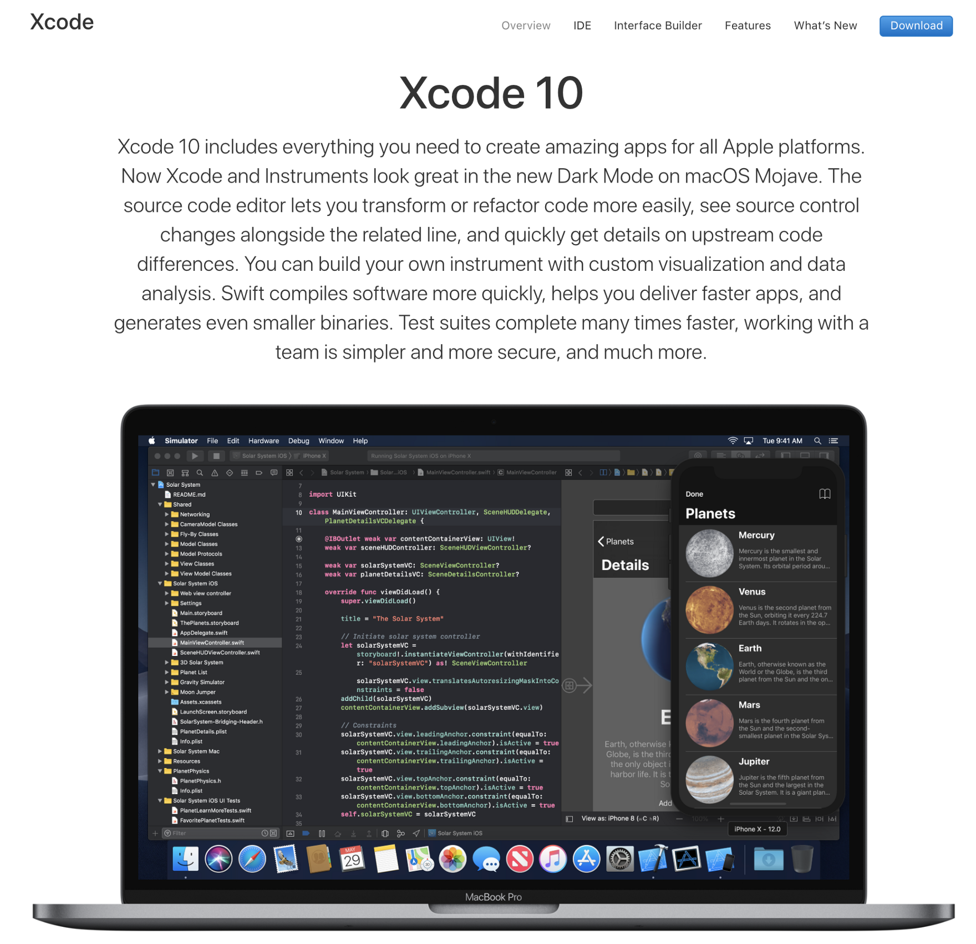

### 2.6: Git instllation <https://git-scm.com/downloads>

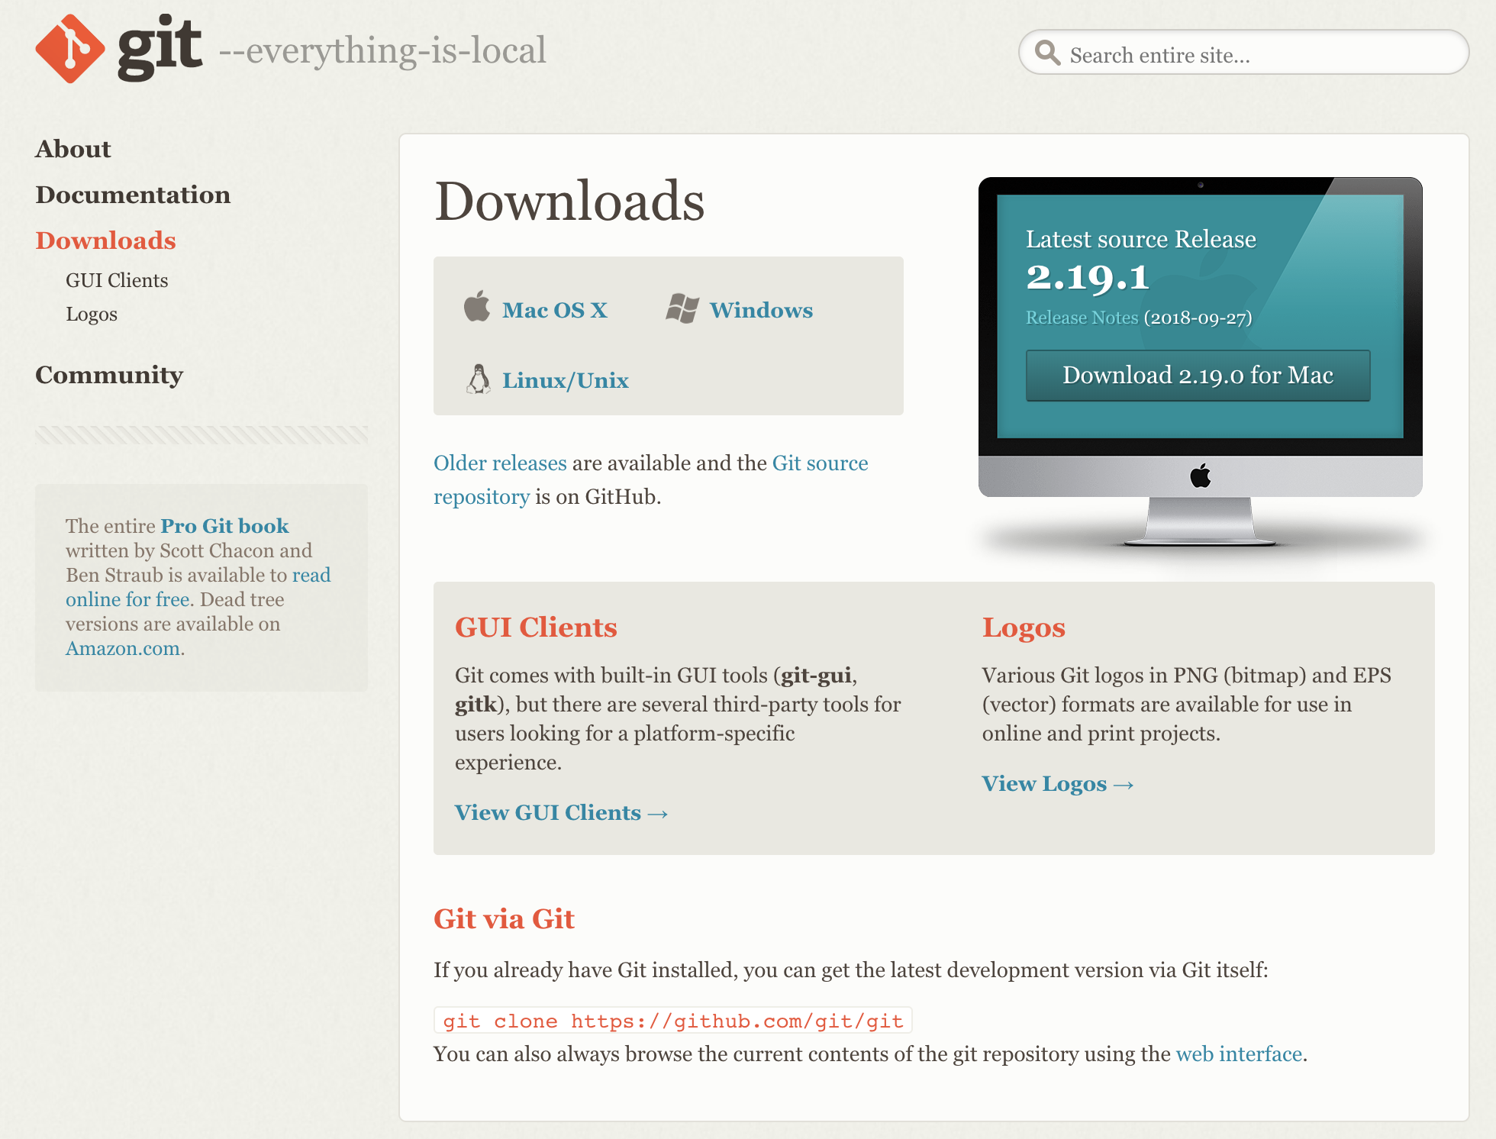

### 2.7: Github desktop client <https://desktop.github.com/>

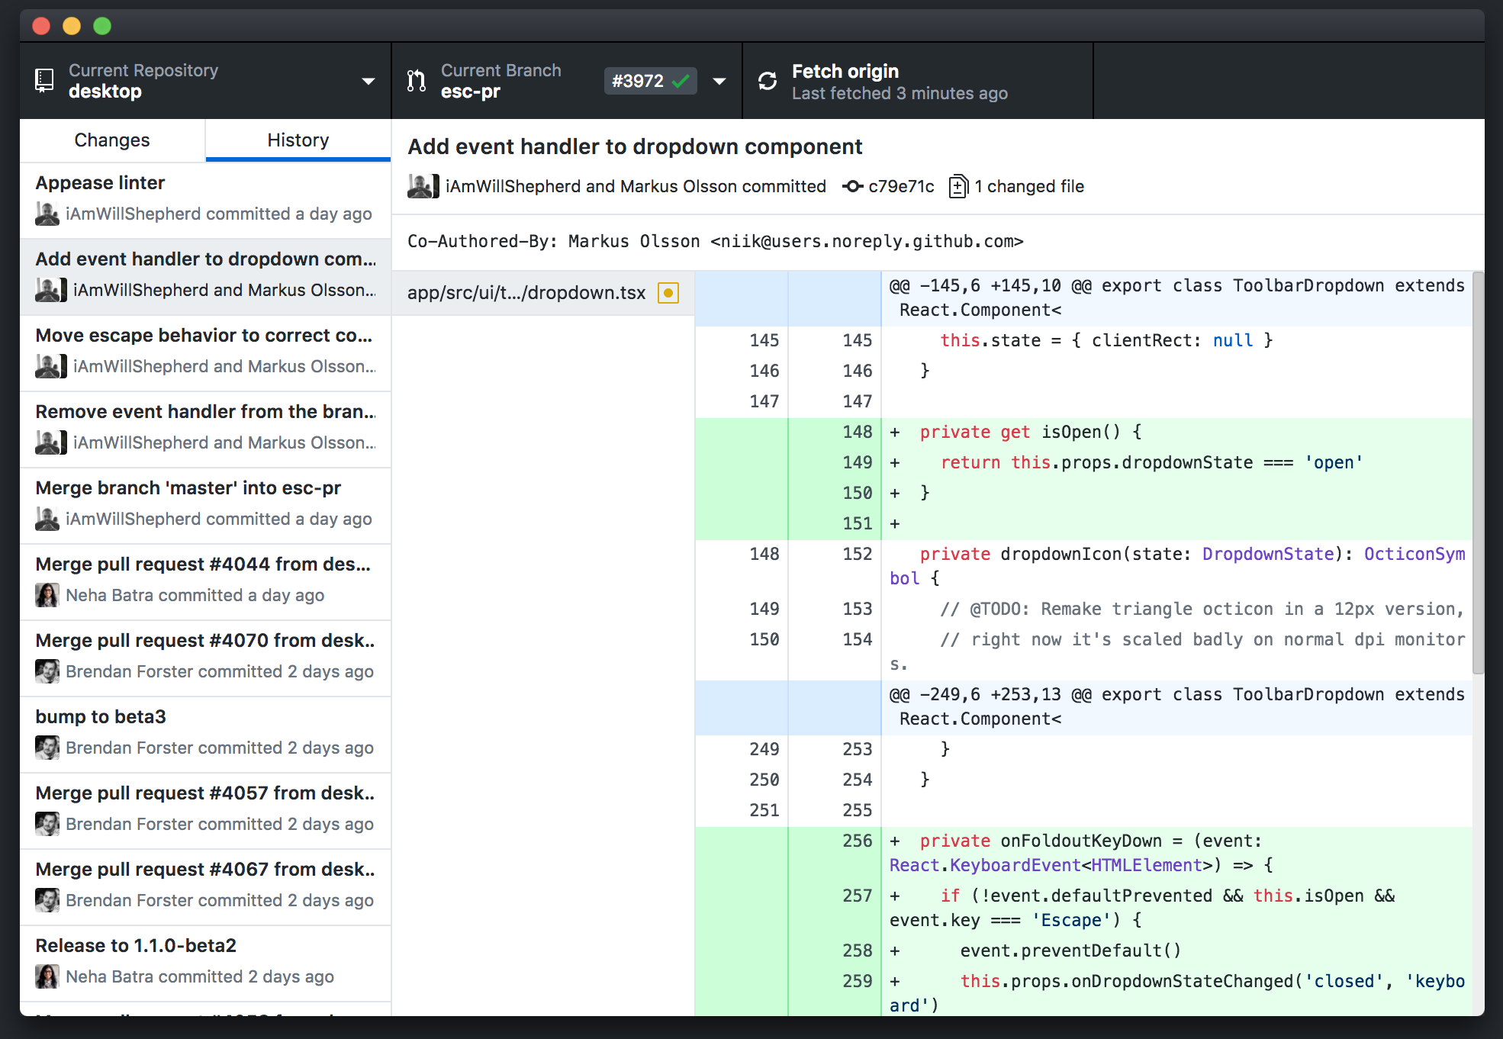

### 2.7: Gitup <https://gitup.co/>

